TASK 3
2.1 TASK 1 – PERFOMANCE WITH UNLLOGED TABLES
Task Result: Add your personal description of what happened and why with screenshots where needed.
- Create simple table
labs.test_simple(a int,b int)
2. Perform insert and check how much time it takes:
insert into test_simple values (generate_series(1,1000000));
1st insert took ~2
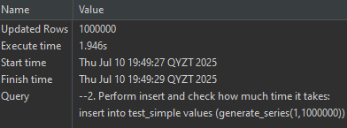
then
insert into test_simple values (generate_series(1,5000000));
The 2nd one took ~10 sec
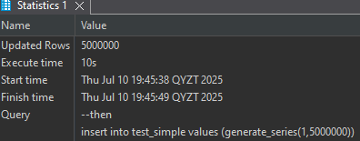
3. Create UNLOGGED table
test_unlogged(a int,b int)
4. Perform insert and check how much time it takes:
insert into test_unlogged values (generate_series(1,1000000));
0.9 seconds for an unlogged table is faster by more than 2 times than in a regular table.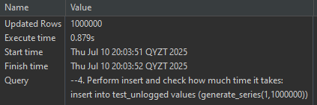
then
insert into test_simple values (generate_series(1,5000000));
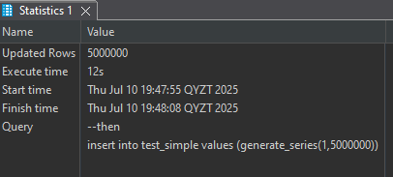
insert into test_unlogged values (generate_series(1,5000000));
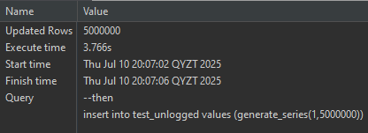

Unlogged Table: Faster, but data is lost after crash; not written to WAL.
WAL is a logging mechanism in PostgreSQL that records changes before they are written to disk. It ensures data durability and supports crash recovery and replication.
Unlogged tables skip WAL, so writes are faster, but data is lost on crash.

--2.2 TASK 2 – UNDERSTANDING INHERITED TABLES
--Task Result: Provide queries where needed. Add your personal description of what happened and why
--with screenshots where needed.
--1. Create inherited table for person:
CREATE TABLE labs.users(user_id INT GENERATED BY DEFAULT AS IDENTITY
PRIMARY KEY, login VARCHAR(30)) INHERITS (person);
Users table also inherits colums from person table
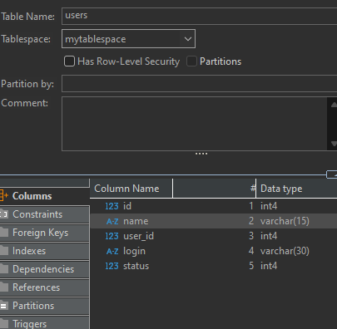
--2. Perform insert into new table:
INSERT INTO users(id, name, login) VALUES (1, 'new Bob', 'NewLogin');
INSERT INTO users(id, name, login) VALUES (999, 'TestUser', 'TestLogin');
I have added (id, name, login) cause without these columns it gave me an error wrong data type
--3. Perform selects:
SELECT * FROM users;
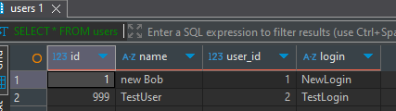
SELECT * FROM person;
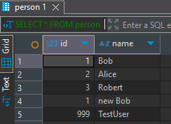
SELECT * FROM ONLY person;
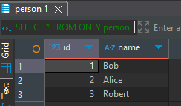
--4. Modify data in person table, check result:
UPDATE person
SET name = 'not Bob'
where id = 1;
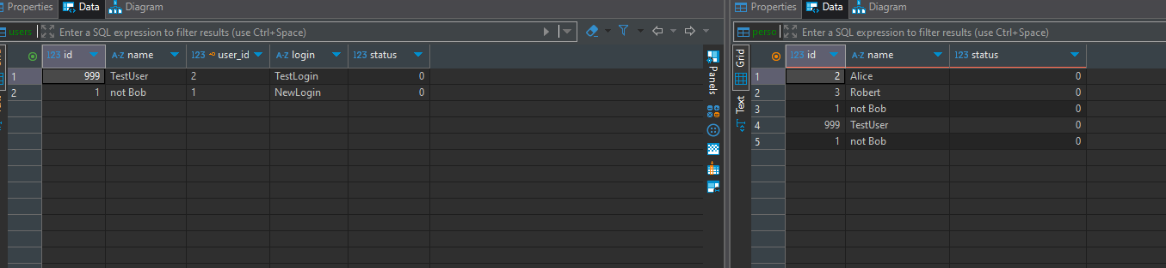

--Rewrite UPDATE to change name for row where id=1 for person table only.
UPDATE ONLY person
SET name = 'yes Bob'
where id = 1;
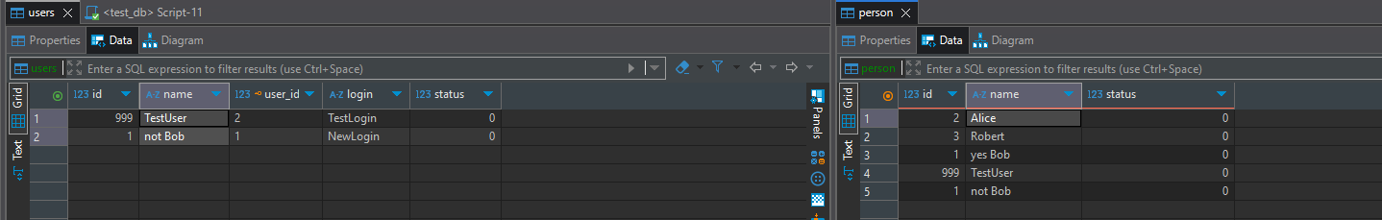
--5. Alter person table and check structure and constraints on both users and person tables:
ALTER TABLE person ADD COLUMN status integer DEFAULT 0;
ALTER TABLE person ADD CONSTRAINT status CHECK (status in (0,1)) NO INHERIT;
ALTER TABLE person ADD CONSTRAINT id UNIQUE (id, name);
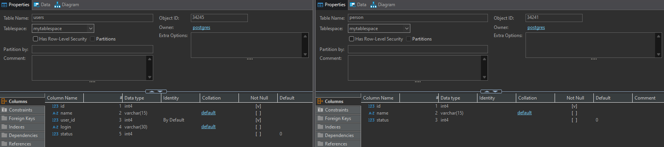

--3. INDEXES
--3.1 TASK 3 - BRIN VS B-TREE
--Task Result: Provide queries where needed. Add your personal description of what happened and why
--with screenshots where needed*.
--* You could also use EXPLAIN ANALYZE for SELECT queries and check the plans differences.
--1. Create table test_index:
CREATE TABLE labs.test_index (
num float NOT NULL,
load_date timestamptz NOT NULL
);

--2. Fill the table with a lot of test data:
INSERT INTO test_index(num, load_date)
SELECT random(), x
FROM generate_series('2017-01-01 0:00'::timestamptz,
'2021-12-31 23:59:59'::timestamptz, '10 seconds'::interval) x;
--Check the table size:
SELECT pg_size_pretty(pg_relation_size('test_index'));
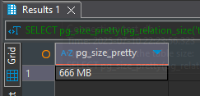
--3. Perform select and check how much time it takes:
SELECT date_trunc('year', load_date), max(num)
FROM test_index
WHERE load_date BETWEEN '2021-09-01 0:00' AND '2021-10-31 11:59:59'
GROUP BY 1
ORDER BY 1;
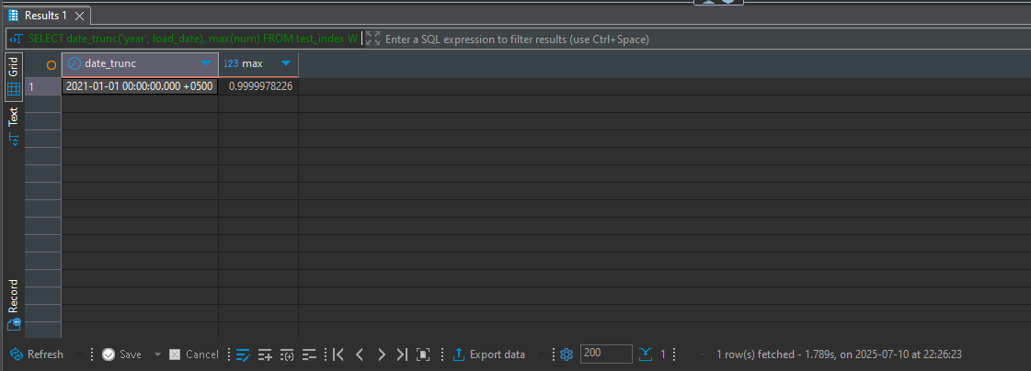
~1.8 sec
With explain analyze
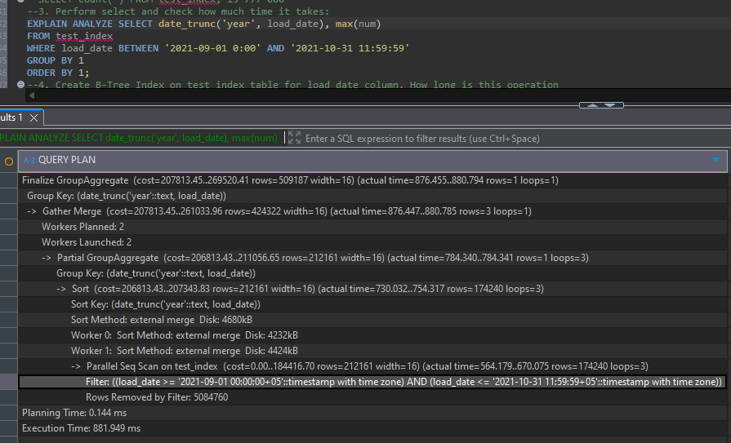
--4. Create B-Tree Index on test_index table for load_date column. How long is this operation
--take? Repeat step 3. Check the index size(see step 1, change ‘test_index’ to name of your
--index). Drop the B-Tree index.
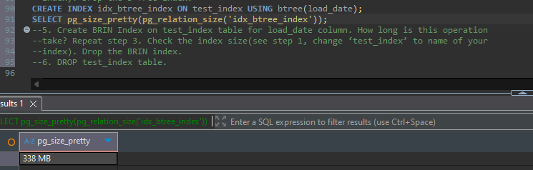
The query from step 3 with btree executed in 0.4 second almost five time faster than without index
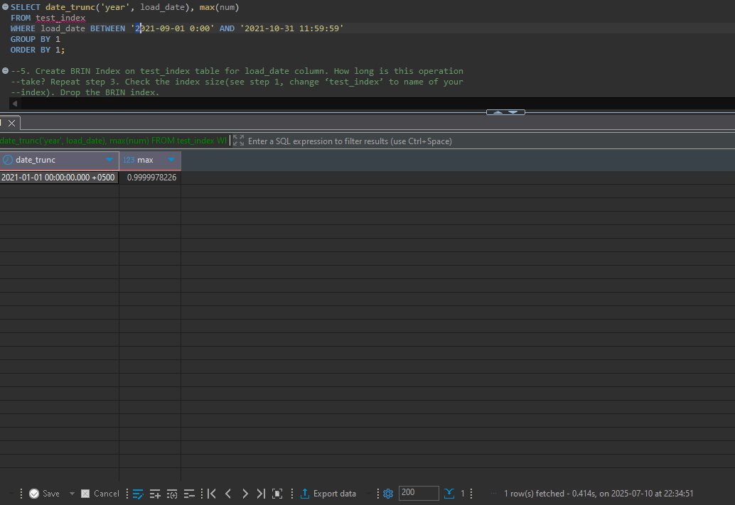
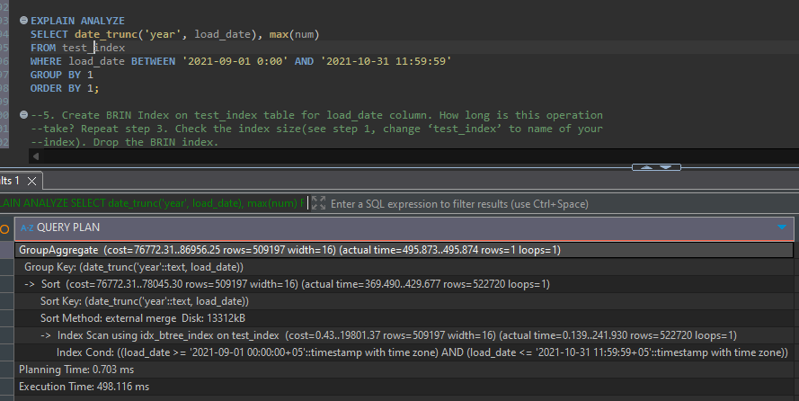
--5. Create BRIN Index on test_index table for load_date column. How long is this operation
--take? Repeat step 3. Check the index size(see step 1, change ‘test_index’ to name of your
--index). Drop the BRIN index.
Size 40 kB

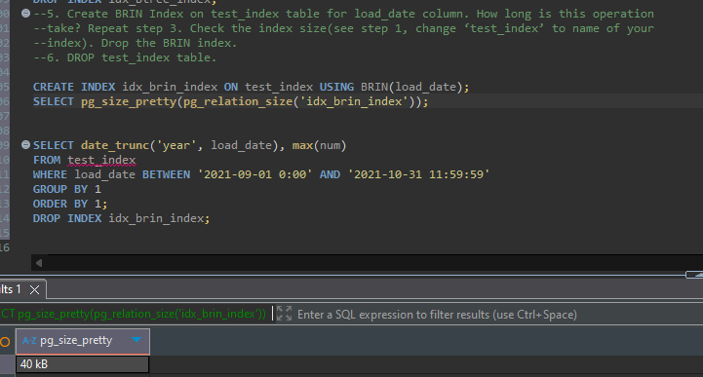

0.36 sec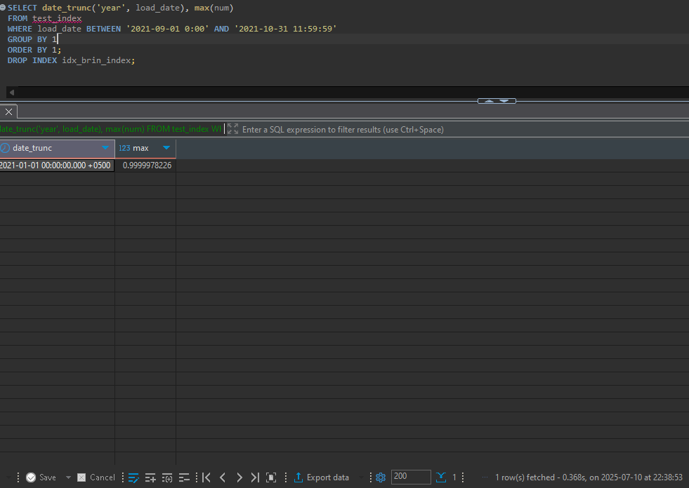
--6. DROP test_index table.
The BRIN index is very effective when the table contains a large amount of data that is physically ordered. BUt, it can lead to less accurate filtering if the data is not properly ordered.
A B-tree index is very effective when a table contains a large amount of data, and queries are related to ranges or sorting, because it provides accurate filtering, even if the data is not ordered.
--3.2 TASK 4 - GIN VS GIST
--Task Result: Provide queries where needed. Add your personal description of what happened and why
--with screenshots where needed.
--1. Create a table and fill with test data:
CREATE TABLE test_index AS SELECT id, md5(id::text) as t_hash
FROM generate_series(1, 10000000) AS id;
--Check the table size(see Task 3).
SELECT pg_size_pretty(pg_relation_size('test_index'));
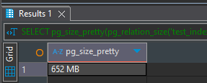
--2. Perform select and check how much time it takes:
SELECT * FROM test_index WHERE t_hash LIKE '%ceea167a5a%';
3.6 sec
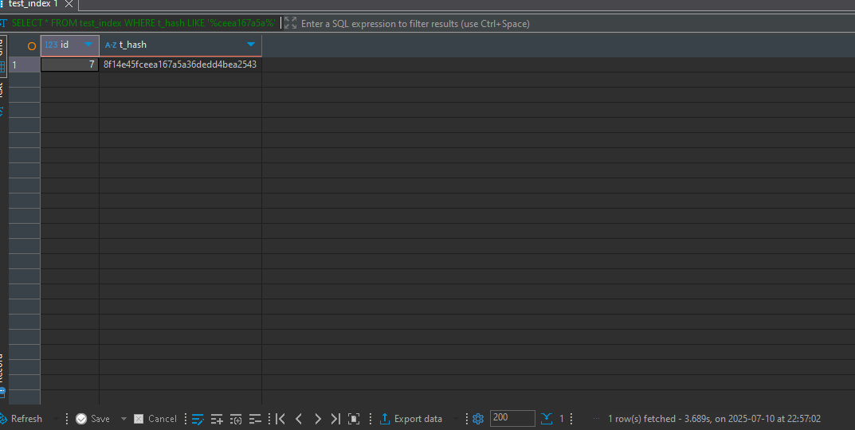
--3. Create GIST Index on test_index table for t_hash column. How long is this operation take?
Repeat step 1. Check the index size(see Task 3). Drop the GIST index.
CREATE EXTENSION pg_trgm;
CREATE INDEX idx_text_index_gist ON test_index USING gist(t_hash
gist_trgm_ops);

7 minutes
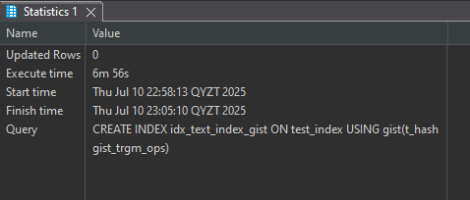
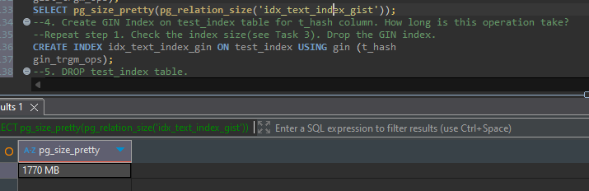
--4. Create GIN Index on test_index table for t_hash column. How long is this operation take?
--Repeat step 1. Check the index size(see Task 3). Drop the GIN index.
CREATE INDEX idx_text_index_gin ON test_index USING gin (t_hash
gin_trgm_ops);
2 min 50 sec
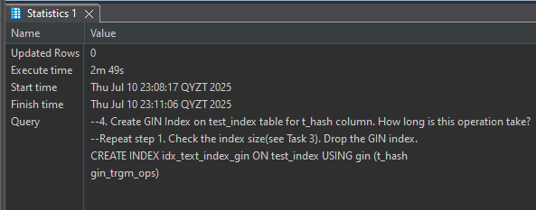
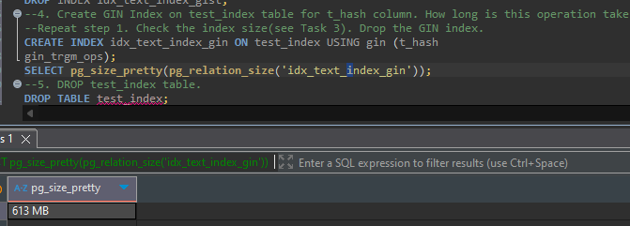
5. DROP test_index table.

--4. FOREIGN DATA WRAPPERS
--4.1 TASK 5 – CSV FILE AS A TABLE
--Task Result: Provide queries where needed. Add your personal description of what happened and why
--with screenshots where needed.
--1. Install file_fdw extension to database and create the SERVER to use, every FOREIGN TABLE
--requires a server:
CREATE EXTENSION file_fdw;
CREATE SERVER test_import FOREIGN DATA WRAPPER file_fdw;
--2. Create the foreign table to connect to the CSV file (cities_list.csv):
CREATE FOREIGN TABLE labs.test_foreign_table
(
LatD INT,
LatM INT,
LatS INT,
NS TEXT,
LonD INT,
LonM INT,
LonS INT,
EW TEXT,
City TEXT,
State TEXT
)
SERVER test_import
OPTIONS
(
filename '"C:\Users\diase\Downloads\cities_list.csv"',
format 'csv',
header 'true',
delimiter ','
);
--3. Select data from the foreign table and count of rows.
SELECT * FROM test_foreign_table;
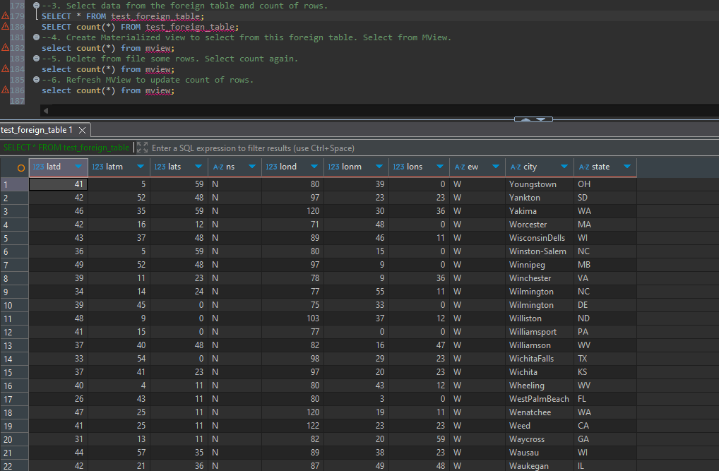
SELECT count(*) FROM test_foreign_table;
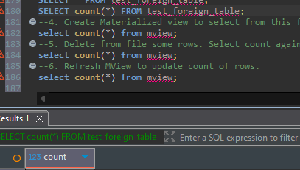
--4. Create Materialized view to select from this foreign table. Select from MView.
select count(*) from mview;
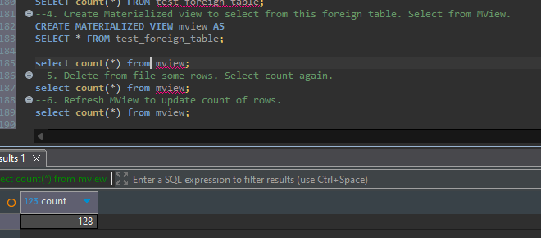
--5. Delete from file some rows. Select count again.
select count(*) from mview;
nothing changed we need to refresh mview
--6. Refresh MView to update count of rows.
select count(*) from mview;
deleted some rows and got new cnt of rows
